**Password:**

Step1: The data in confirm password and password are not the same, the website will not remind to the user.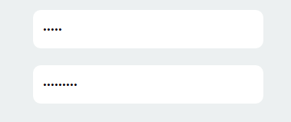

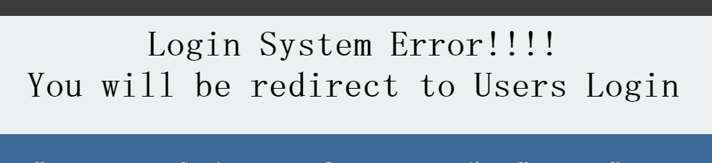Step 2: when I submit the register, the system only tell the user that login system error.

**Services:**

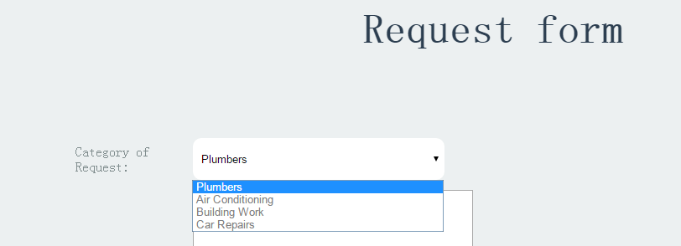Step 1: The category of request in request form only has 4 types of services.

Step 2: Our website provides 5 services. “Electrician” has not been added in the category of request.

